Section | BEAVERS delete as appropriate
Week | 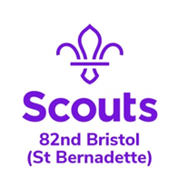  10 |  | Date | 24/06/2020
Zoom Meeting Recap:
We started the session with our BEAVERS sign

Jemma showed us pictures of everyone in their disguises that they sent over this week and we had to guess who was who!

Clare then talked about our task for next week (see below)

We played the flag game and then finished off with an alphabet game – naming boys and girls names from each letter of the alphabet in turn.

We finished with our BEAVERS sign again

Scouting from home task:
Badge/Activity |  | Digital Citizen
Requirements |  | Name parts of a computer
Your Task |  | Research and learn the different parts of a computer. Produce a poster to share what you found out!
Useful Resources
Next Step |  | Complete the above task and have it ready to show next week on Zoom!

