Fill in the missing Compass points, colour in and then either post it on our facebook page or scan and send in by e-mail.

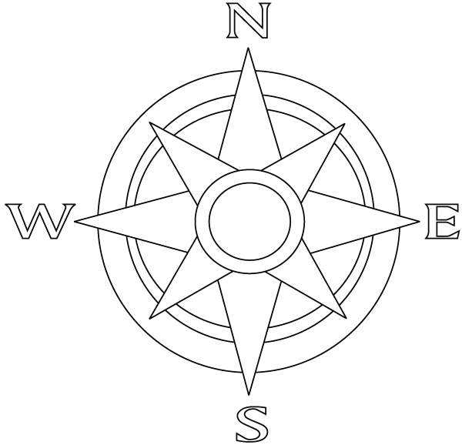

When we receive your completed sheet we will mark off part of your Navigation level 1 Badge
