Section | SCOUTS
Week | 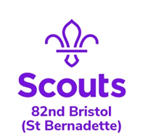  5 |  | Date | 20/05/2020
Zoom Meeting Recap:
This week we started working on our Navigator staged badge by playing ‘Map Symbol Bingo’.
We then had a quick catch up with each other to see how everyone is spending time during isolation.

Scouting from home task:
Badge/Activity |  | Navigator Badge - Preparation
Requirements |  | Various stages
Your Task |  | This week we would like you to spend some time looking at the Ordnance Survey website (link below) to research some map skills. There are plenty of resources to look through and use, you can read each section, make notes and be sure to watch the videos!  We will be putting what you have learnt to the test on our next zoom call when we take part in the quizzes and games on the same website.  Please feel free to make notes on what you have learnt and we would love to see any photos of you guys practicing your skills prior to the next task we set.
Useful Resources |  | https://www.ordnancesurvey.co.uk/mapzone/map-skills
Next Step |  | Be ready to put your skills to the test in our map skills activity next week (27/05).  We hope to see as many of you as possible joining our Family Zoom Quiz on Monday 25/05 too!  Stay Safe
